

**MADHAV INSTITUTE OF TECHNOLOGY AND SCIENCE, GWALIOR**

(**A Govt. Aided UGC Autonomous & NAAC Accredited Institute Affiliated to RGPV, Bhopal)**

A Minor Project on

**WATER SAVING IRRIGATION SYSTEM USING**

**555 TIMER**

**Submitted By**

Mohil Jain

( 0901EE181068)

Rajarsh Dwivedi

(0901EE181085)

**Submitted to:** :

Dr.Vijay bhuria Prof.Tarun Shrivastava

Dr.Punjan Dohare Er.Rajendra Singh Yadav

DEPARTMENT OF ELECTRICAL ENGINEERING

## (Jan-may 2021)

### INDEX

**(1)INTRODUCTION 1**

**(2)CIRCUITDIAGRAM 2**

**(3)COMPONENTS 3-4**

**(4)WORKING 5**

**(5)ADVANTAGES 6**

**(6)FUTURE SCOPE 7**

**(7)RESULT 8**

**(8)CONCLUSION 9**

**(9)ESTIMATED COST 10**

**(10)REFERENCES 11**

### INTRODUCTION:

As the name of our project that is WATER SAVING IRRIGATION SYSTEM with the help of the 555 timer is a step to utilize some new engineering techniques. This technique will be a very good option for the small and medium farmers who suffer every year just because of failure of crops that tookplace every year that took place every year. Implementation of this technology has a wide scope in the nearby future.

**CIRCUIT DIAGRAM**

.

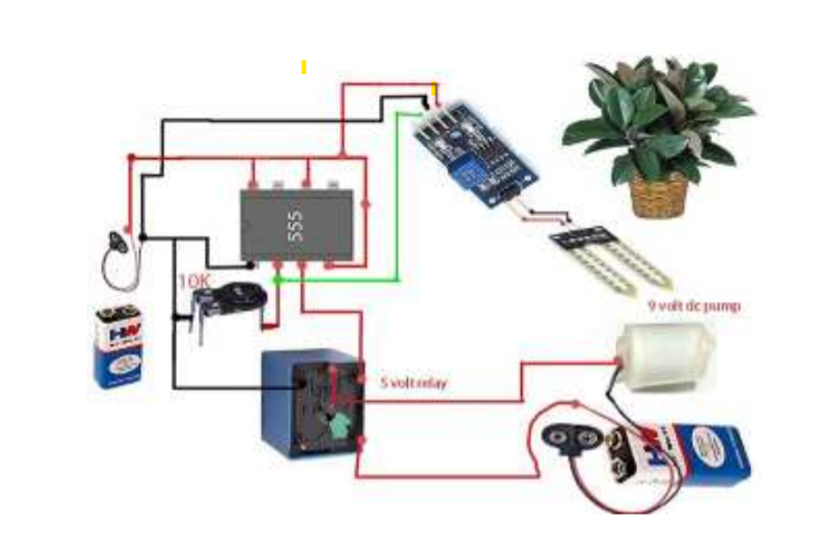

COMPONENTS:

**(1 ) 555 TIMER IC**

The circuit diagram of Automatic plant watering system is shown in figure 1 and is built aroundone of the most popular IC, IC555. It also includes pump and other passive components 555 IC:- The 555 timer IC is an integrated circuit chip used in a variety of timer, pulse generation,and oscillator applications. The 555 can be used to provide time delays, as an oscillator, and as a flip-flop element. Derivatives provide two (556) or four (558) timing circuits in one package.

**(2) RELAY**

Relay is an electrically operated switch. Several relays use a magnet to automatically operate a switch, however alternative in operation principles are used, like solid state relays. Relays are used wherever it's necessary to regulate a circuit by a separate low-power signal, or wherever many circuits should be controlled by one signal. The essential relays were handling in long distance communicate circuits as amplifiers, they unbroken the signal coming back in from one circuit and retransmitted it on another circuit.

**(3)SOILMOISTURE DETECTOR**

Soil moisture sensors measure the humidity of water content in soil. Since the direct hydrometric measuring of free soil wetness needs removing, drying, and coefficient of a sample, soil wetness sensors). live the meter water content indirectly by victimization another property of the soil, like electrical phenomenon, non-conductor constant, or interaction with neutrons, as a proxy for the wetness content.

**(4)LED BULB**

LED is a semiconductor light source that emits light when current flows through it. When a current flows through the diode, electrons are able to recombine with electron holes within the device, releasing energy in the form of photons.

**(5)RESISTOR**

A resistor is**a passive two-terminal electrical component that implements electrical resistance as a circuit element.** In electronic circuits, resistors are used to reduce current flow, adjust signal levels, to divide voltages, bias active elements, and terminate transmission lines, among other uses.

**(6)BATTERY**

A battery is**a power source consisting of one or more electrochemical cells with external connections for powering electrical devices such as flashlights, mobile phones,** and**electric** devices.Here battery of 9v is used.

**WORKING:**

The aim of this implementation was to demonstrate that the Water Saving irrigation system can be used to optimize /reduce water usage. It can also be a photovoltaic irrigation system which consists of a solar powered that is the soil moisture sensor and temperature sensor placed under the soil where plants roots are reached which is a distributed network. The system has a water level sensor which will indicate the presence of water level in tank. A software application was advanced by programming the verge values of soil moisture water level .

Monitor the moisture content of the soil using a soil moisture sensor and the water level of the tank using a float switch. Turn the motor ON when the soil moisture falls below a certain reference value and if there is enough water in the tank.

Circuit is not that much complicated. We use the basic concept in this circuit i.e. soil have high resistance when **it** is

Dry and low resistance when it is wet.

By using this concept we will make the system work. We insert two probes in the soil in such a way that that they will conduct when the soil is wet and they will not conduct when the soil is dry. So, when the probes do not conduct, system will automatically detect this condition with the help of HEX inverter which will become high when the input is low.

**ADVANTAGES:**

1.The circuit can be used to measure the loss of moisture in the soil over time due to evaporation and intake.

2.Minimizes water waste and improves plant growth.

3.The circuit is designed to work automatically and hence, there is no need for any human intervention.

4.The project is usually intended for small gardens and residential environment.

5.It is not so costly,it is cost efficient.

**FUTURE SCOPE:**

1. GSM can be added for sending SMS to the concerned person in case of any problem.
2. Other Parameters such as ambient temperature, light intensity & humidity can be measured.
3. Pesticides & fertilizers can also be added automatically in the water.

**RESULT:**

The system was tested in the field conditions and results revealed that, system would be a best option for medium size agriculture field When all probes were dry, water pump was switched on until all the probes were getting wet. As well as when all probes were wet, it allocated to dry till two probes and utilize the water and power sustainable manner. If further reduction of the moisture of the soil occurred, it leaded to switch on the pump till all probes getting wet. Because of this automated system water wastage of the tested field could be reduced by 50% of normal irrigation wastage and reduce evapo transpiration by induced dark time operation. Beside human attention was reduced on irrigation due to automation. Irrigation becomes easy, accurate and practical with the impression above shared and can be executed in agricultural fields.

.

### CONCLUSION

Thus the “Water Saving Irrigation system” based on soil moisture has been designed and tested successfully. It has been developed by integrated features of all the hardware components used. Presence of every module has been reasoned out and placed carefully, thus contributing to the best working of the unit the moisture sensors measure the moisture level (water content) of the different plants. If the moisture level is goes to be below the desired and limited level, the moisture sensor sends the signal to the Arduino board which triggers the Water Pump to turn ON and supply the water to respective plant using the Rotating Platform/Sprinkler. When the desired moisture level is reached, the system halts on its own and the water Pump is turned OFF.Thus, the functionality of the entire system has been tested thoroughly and it is said to function successfully.

**ESTIMATED COST**:

The estimated cost of project is around Rs 600.

**REFERENCES:**

[1] Y. Kim and R. G. Evans, ―Software design for wirelesssensor-basedsite-specific irrigation

[2] D. K. Fisher and H. A. Kebede, ―A low-cost microcontroller-basedsystem to monitor crop temperature and water status.

[3] K.Srikar ,M.Akhil ,V.Krishna reddy,” Execution of Cloud Scheduling Algorithms”,International Innovative Research Journal of Engineering and Technology.

THANKYOU